For more information, interviews, or images:
Marilynne Friedman, Beit Halochem Canada; marilynne@beithalochem.ca; 905.695.0611

Courage in Motion 2020: Side by Side rolls on October 12
Whether you prefer riding outdoors, indoors, up north, or down east,
make 2020 your year to come along for the ride

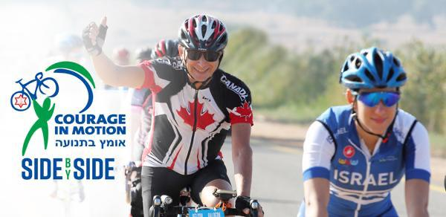
(September 22, 2020 - Concord, ON) The 13th annual Courage in Motion, an initiative of Beit Halochem Canada, Aid to Disabled Veterans of Israel, is staying home. While Courage in Motion will not take us through southern Israel this fall, there is good news: our premier annual fundraising ride, supporting the rehabilitation of more than 50,000 Israeli men and women injured in the line of duty, continues to roll in 2020. Courage in Motion: Side by Side takes place throughout Canada and Israel on Monday, October 12 (Canadian Thanksgiving).

On registering, each Canadian cyclist will be teamed with an Israeli veteran. Pairs will be encouraged to connect prior to the ride and, on ride day, set out to cycle together side by side in different countries. The restructured event allows more cyclists to participate from anywhere in Canada - including those who prefer indoor biking.

Lisa Levy, National Executive Director of Beit Halochem Canada, is the ride’s founder. An avid cyclist herself, she says “Each year, as this five-day journey takes us through Israel, old friends reunite and new friendships form. It is an incredible experience. However, it’s also our largest fundraiser on behalf of the men and women injured while protecting Israel for us all. With travel impossible this year, we regrouped to ensure our disabled veterans would still be helped. The one-day Side by Side has been organized with our cyclists’ collaboration and input. It is hoped that many will take the opportunity to ride with an Israeli Hero - wherever they are in Canada.”

Registration fee for Side by Side is $180 CDN, including a jersey + $80 tax receipt. Fundraising goal is $500 CDN, with all donations receiving full tax receipts.

Event proceeds fund programming for Israel’s disabled veterans and their families. Cycling is particularly thriving at our leading-edge Beit Halochem Centres as the activity easily accommodates social distancing and, in the current environment, increased demand is anticipated.

Additional information, registration for Courage in Motion: Side by Side, as well as images from last year’s ride are available here.

We look forward to next year’s Courage in Motion taking place in Israel from October 17-21, 2021. Registration is expected to open in March 2021.

COURAGE IN MOTION 2020: SIDE BY SIDE
FACT SHEET

WHAT? Our premier fundraising event, Courage in Motion, an annual five-day ride taking place in (and through) Israel has been restructured to a one-day event, allowing more Canadian cyclists the opportunity to ride with Israeli Heroes.

WHEN? Monday, October 12 (Thanksgiving) at any time chosen by our participants.

WHO? Canadian registered cyclists and Israeli injured veterans.

WHERE? Across Canada and throughout Israel. Indoors or outdoors. Up north or down east. Out west or on the prairies. Anywhere our cyclists are is where the ride takes place!

HOW? Each Canadian cyclist will be paired with an Israeli veteran – riding side by side, while apart, in different countries. Cyclists are encouraged to connect with their partners before and during the ride. More information/registration

COST? Registration fee: $180 (includes a cycling jersey and an $80 tax receipt)
Fundraising goal: minimum $500 (fully tax deductible)

WHY? Event proceeds fund programming for Israel’s disabled veterans and their families at Beit Halochem Centres. Cycling is thriving at these leading-edge rehabilitation facilities as it easily accommodates social distancing. In the current environment, it is highly anticipated that demand will continue to increase.

- 30 -

ABOUT BEIT HALOCHEM CANADA
Beit Halochem Canada, Aid to Disabled Veterans of Israel is committed to rehabilitating, rebuilding, and enhancing the lives of over 50,000 Israelis who have become disabled in the line of duty or through acts of terror. Leading-edge Beit Halochem Centres in Jerusalem, Tel Aviv, Haifa, Nahariya, and Beer Sheva, and the future Ashdod provide individualized therapies, specialized sports rehabilitation training, cultural arts, and family-oriented programming. Beit Halochem is the sole organization to take care of Israel’s wounded heroes from the time they are injured and for the rest of their lives. We assist them on the long and difficult journey to regain their health and independence, empowering them as they strive to reclaim their lives and be productive members of Israeli society.

