For immediate release
For more information, interviews, or images:
Marilynne Friedman, Beit Halochem Canada: marilynne@beithalochem.ca; 905.695.0611

Courage in Motion 2019. A five-day bike ride. A lifetime of memories.
From October 27-31, cyclists will ride through northern Israel
alongside Israel’s injured veterans and members of the Israel Cycling Academy

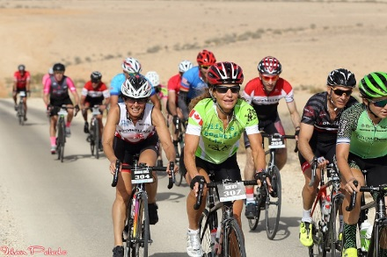
(Toronto - August 6, 2019) – From October 27 - 31, 2019, Courage in Motion (CIM) will welcome Canadian and international cyclists to ride alongside Israel’s injured veterans, victims of terror, and members of the Israel Cycling Academy team.

The Beit Halochem Canada, Aid to Disabled Veterans of Israel initiative, now in its 12th year, is a significant fundraiser, supporting both the purchase of equipment and facilitating programming at five state-of-the-art Beit Halochem rehabilitation centres across Israel. Cyclists’ fundraising also provides the opportunity for the Centres’ disabled members to participate in this extraordinary experience.
Courage in Motion 2018 Photo: Idan Peled

Cyclists ride 50 – 120 kilometres daily, choosing from five fully supported routes offering various levels of challenge. No matter the route, each showcases Israel’s lush landscape, including the magnificent Hula Valley and the remarkable historic sites of the Galilee, Tiberias, and the Golan Heights.

Lisa Levy is Beit Halochem Canada’s Executive Director, Courage in Motion founder, and an annual participant. She says, “Year after year, our international cyclists return.” Why do they keep coming back? Former NHL all-star Keith Primeau and Canadian cycling champion Eon D’Ornellas, both of whom first experienced last year’s ride, explain.

States Primeau, “Courage in Motion is one of those unforgettable life experiences. It connected me with a culture that I knew little about and a community which is incredibly proud of its history and heritage. It was humbling to see the organizers and riders so engaged in the stories of those who lay their lives on the line every day to protect their nation. While this was an once-in-a-lifetime journey, it’s one I am looking forward to repeating this year – this time, accompanied by my daughter!”

D’Ornellas adds, “My partner, Bonnie and I experienced last year’s Courage in Motion and it was one of the the best trips we’ve ever done. The friendliness of everyone … including the Canadian riders, Israeli veterans, organizers and support staff, plus the outstanding hospitality, added to our enjoyment of the event. It was a great cycling experience with other like-minded cyclists. We are both excited to return this year.”

Delicious meals and nutritious snacks are provided throughout the event. Group activities follow each day’s ride including a night walking tour of Tiberias and an incredible evening with Israel’s heroes sharing their inspiring stories.

More information and registration for Courage in Motion 2019 is here.
-30-
Beit Halochem Canada, Aid to Disabled Veterans of Israel is committed to rehabilitating, rebuilding, and enhancing the lives of over 51,000 Israelis who have become disabled in the line of duty or as victims of terror. Leading-edge Beit Halochem Centres in Jerusalem, Tel Aviv, Haifa, Beer Sheva, and Nahariya offer individualized therapies, specialized sports rehabilitation training, and cultural arts, and family-oriented activities. Academic scholarships are available as our veterans strive to be productive members of Israeli society, as is PTSD counselling for both veterans and their spouses.

Follow Beit Halochem Canada on Facebook
Follow Beit Halochem Canada on Instagram
Follow Beit Halochem Canada on Twitter

